Yield Prediction from Management Practices Using Machine Learning
Technical Modeling Report
1. Objective
The objective of this study was to develop a machine learning model capable of predicting crop yield using farm management practices, crop identity, and spatial information. The ultimate goal is to deploy this model into a backend system and graphical user interface (GUI) platform that allows:
- Individual farmers enter their crop and management data and receive yield predictions.
- Enterprise partners (e.g., General Mills) to upload batch Excel files and obtain field-level yield estimates.
The dataset contains over 40,000 field observations across multiple years, crops (26 unique crops), and counties across the United States.
2. Dataset Overview
The dataset includes:
- Target variable: Yield
- Crop identity (crop_name_en)
- Variety information
- Herbicide and fertilizer information
- Nutrient rates (N, P, K, urea, etc.)
- Total cultivated acres
- Location information (county)
- Year
The dataset is heterogeneous, spanning multiple crops with very different yield scales and agronomic responses.
3. Data Preprocessing
3.1 Handling Missing Values
- Rows with missing yield values were removed.
- Categorical features were converted to string type.
- Missing categorical values were encoded as "Missing" to allow CatBoost to treat them as valid categories.
3.2 Crop-Level Yield Standardization
Because yield varies substantially across crops (e.g., wheat vs corn vs sorghum), direct modeling of raw yield would bias the model toward high-yield crops.
To address this, yield was standardized within each crop:
$Yield_{norm}=\frac{Yield-μ_{crop}}{σ_{crop}}$
Where:
- $μ_{crop}$is the crop-specific mean yield
- $σ_{crop}$is the crop-specific standard deviation
Crops with single observations or zero variance were handled safely by setting standard deviation = 1. Predictions were later back-transformed to the original yield scale for interpretation. This approach improves stability and ensures fair learning across crops.
4. Model Selection
4.1 Why CatBoost?
CatBoostRegressor was selected for the following reasons:
- Native support for categorical variables
The dataset contains high-cardinality categorical features (crop names, counties, varieties, herbicide names).
- Strong performance on heterogeneous tabular data
Agricultural data often contain nonlinear interactions and sparse patterns.
- Built-in handling of categorical encoding: Avoids manual one-hot encoding explosion.
- Robustness to missing numerical values.
- Strong performance with limited feature engineering.
CatBoost is well-suited for production-level agricultural decision support systems.
5. Model Configuration
The final model used:
- Loss function: RMSE
- Iterations: 5000
- Learning rate: 0.03
- Tree depth: 10
- L2 regularization: 8
- Early stopping rounds: 200
Early stopping prevents overfitting by monitoring validation performance.
The deeper trees allow modeling complex interactions between crop type, management practices, and geography.
6. Model Validation Strategies
Because agricultural data are spatially and biologically structured, multiple validation strategies were tested.
6.1 Random 5-Fold Cross Validation
Data were randomly split into five folds then 20 folds.
Result:
- R² ≈ 0.81 (40min training)
- R² ≈ 0.85 (3 hours training)
- Strong predictive performance
Interpretation:
The model performs well when training and testing data share similar crop and location patterns.
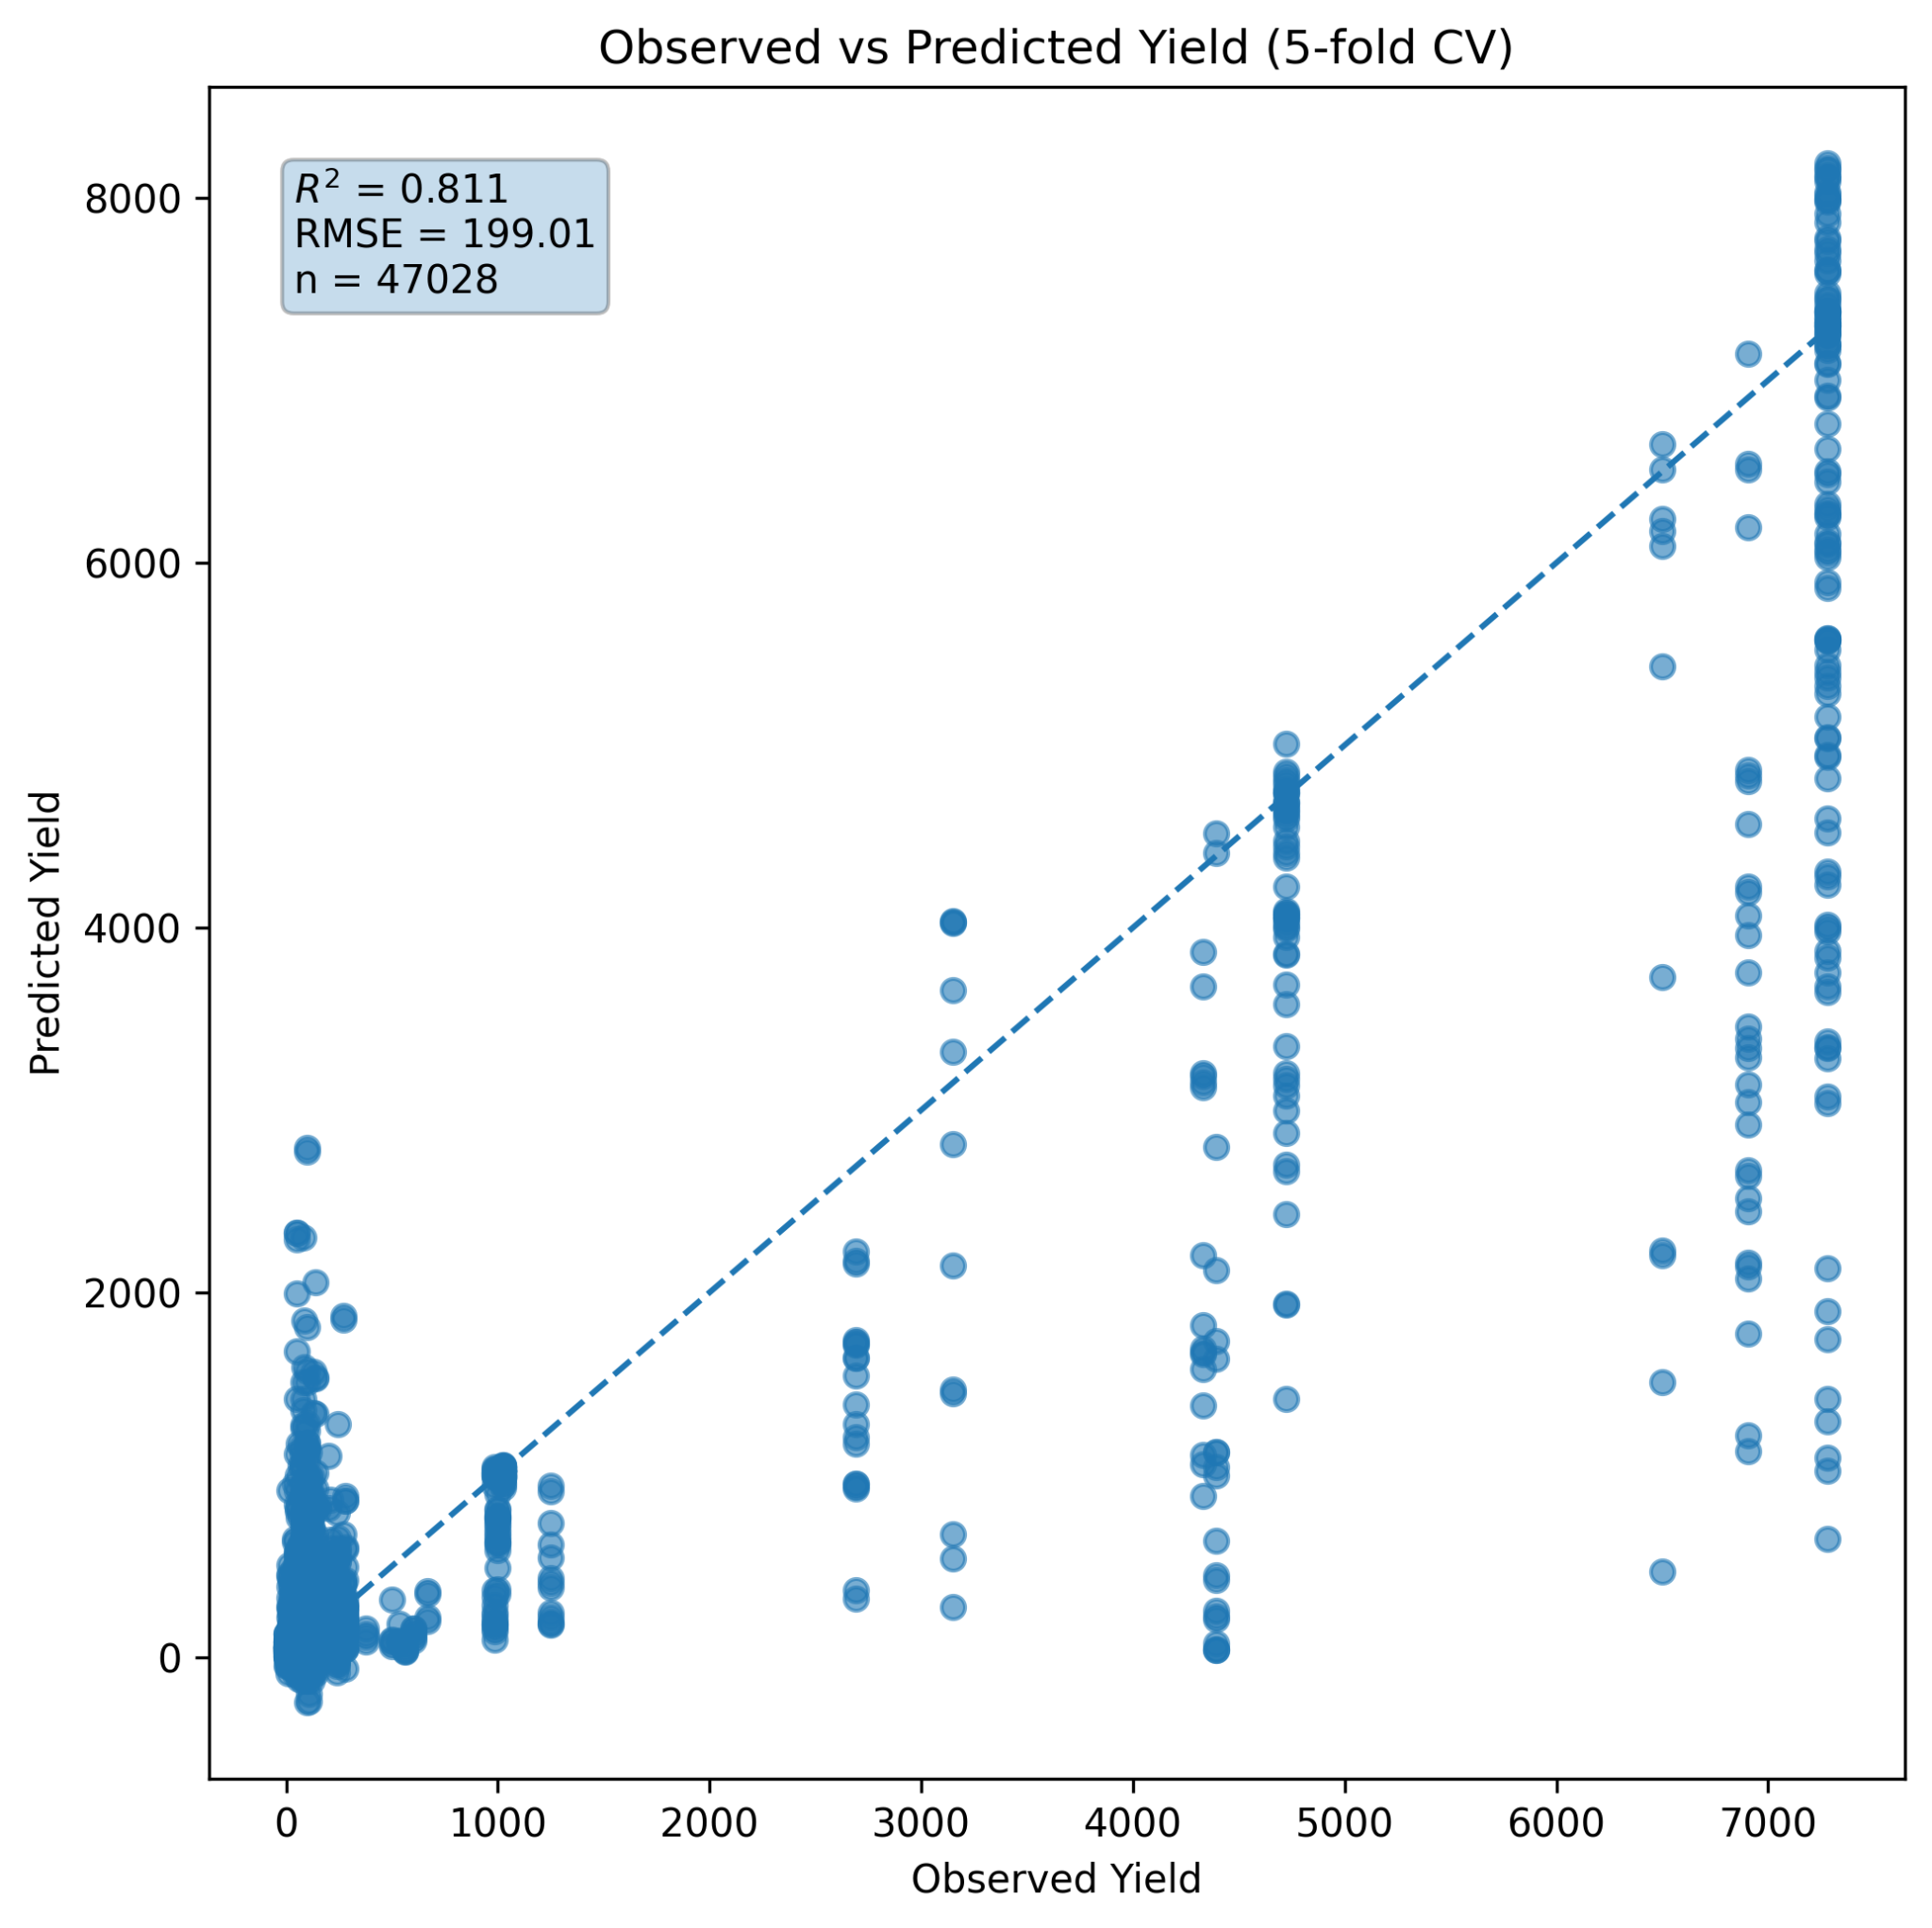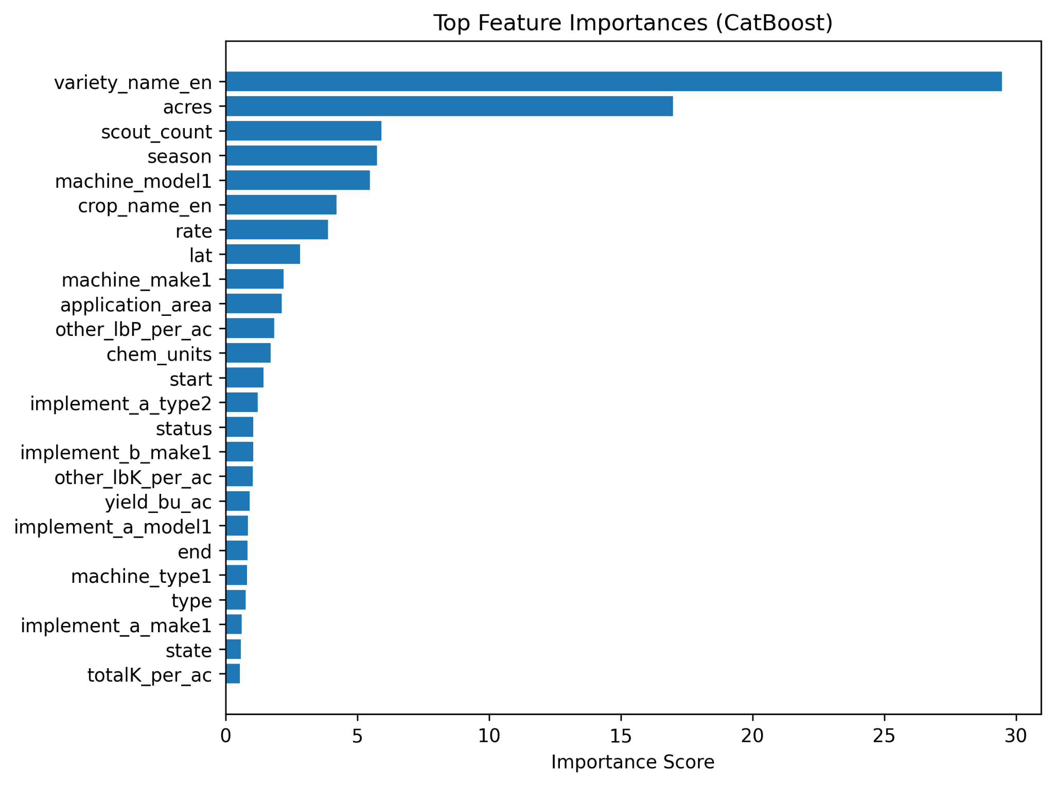
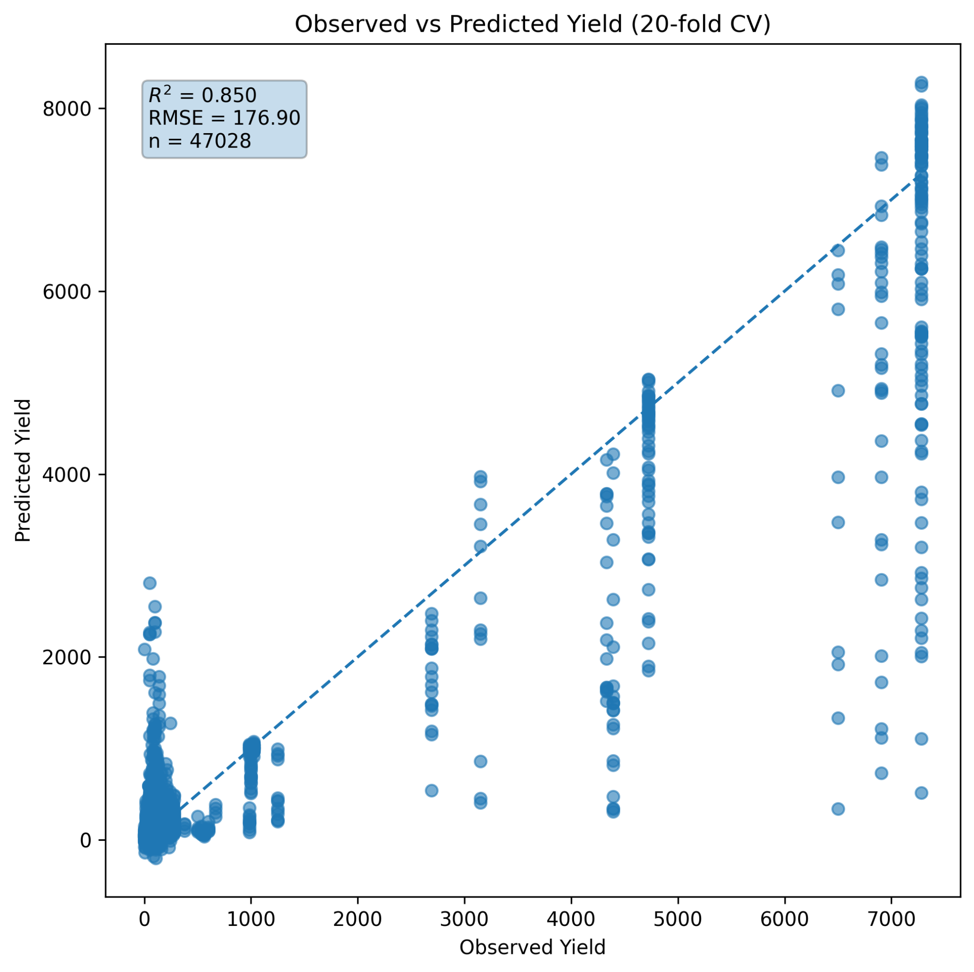
Figure 1: Model outputs: Observed vs Predicted Yield Using Random CV and features importance score
6.2 Grouped Cross Validation by County
Entire counties were held out during testing.
Result:
- R² ≈ 0.07
Interpretation:
Model performance collapses when predicting completely unseen counties. This indicates yield patterns are strongly location-dependent. Management variables alone are insufficient to generalize spatially.
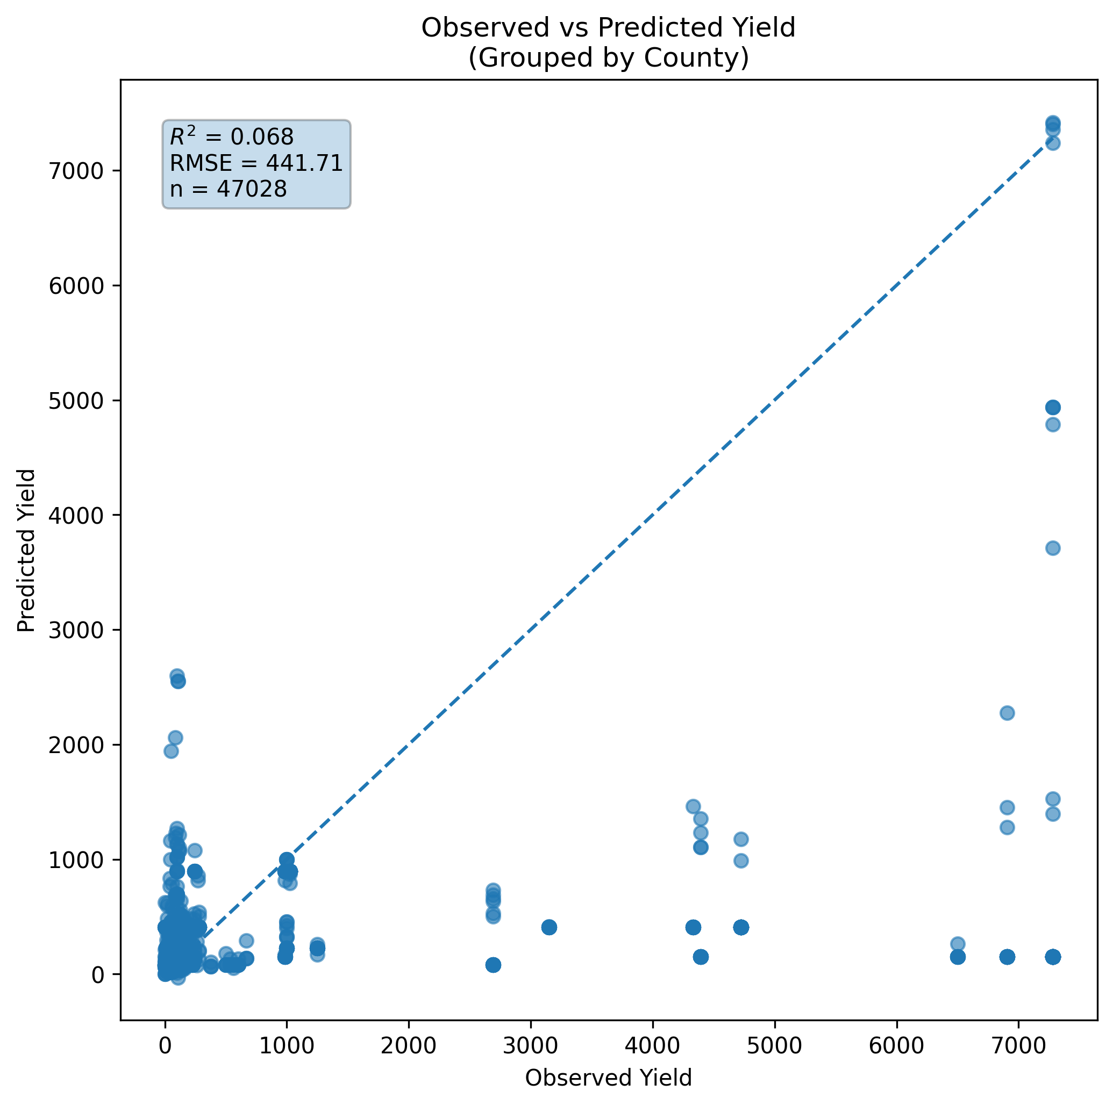
Figure 2: Observed vs Predicted Yield Using Grouped by County CV 5 Fold

6.3 Grouped Cross Validation by Crop
Entire crops were held out during testing.
Result:
- R² ≈ 0.017
Interpretation:
The model cannot generalize to completely unseen crops. Yield responses are crop-specific. This is biologically expected because management × crop interactions differ substantially.
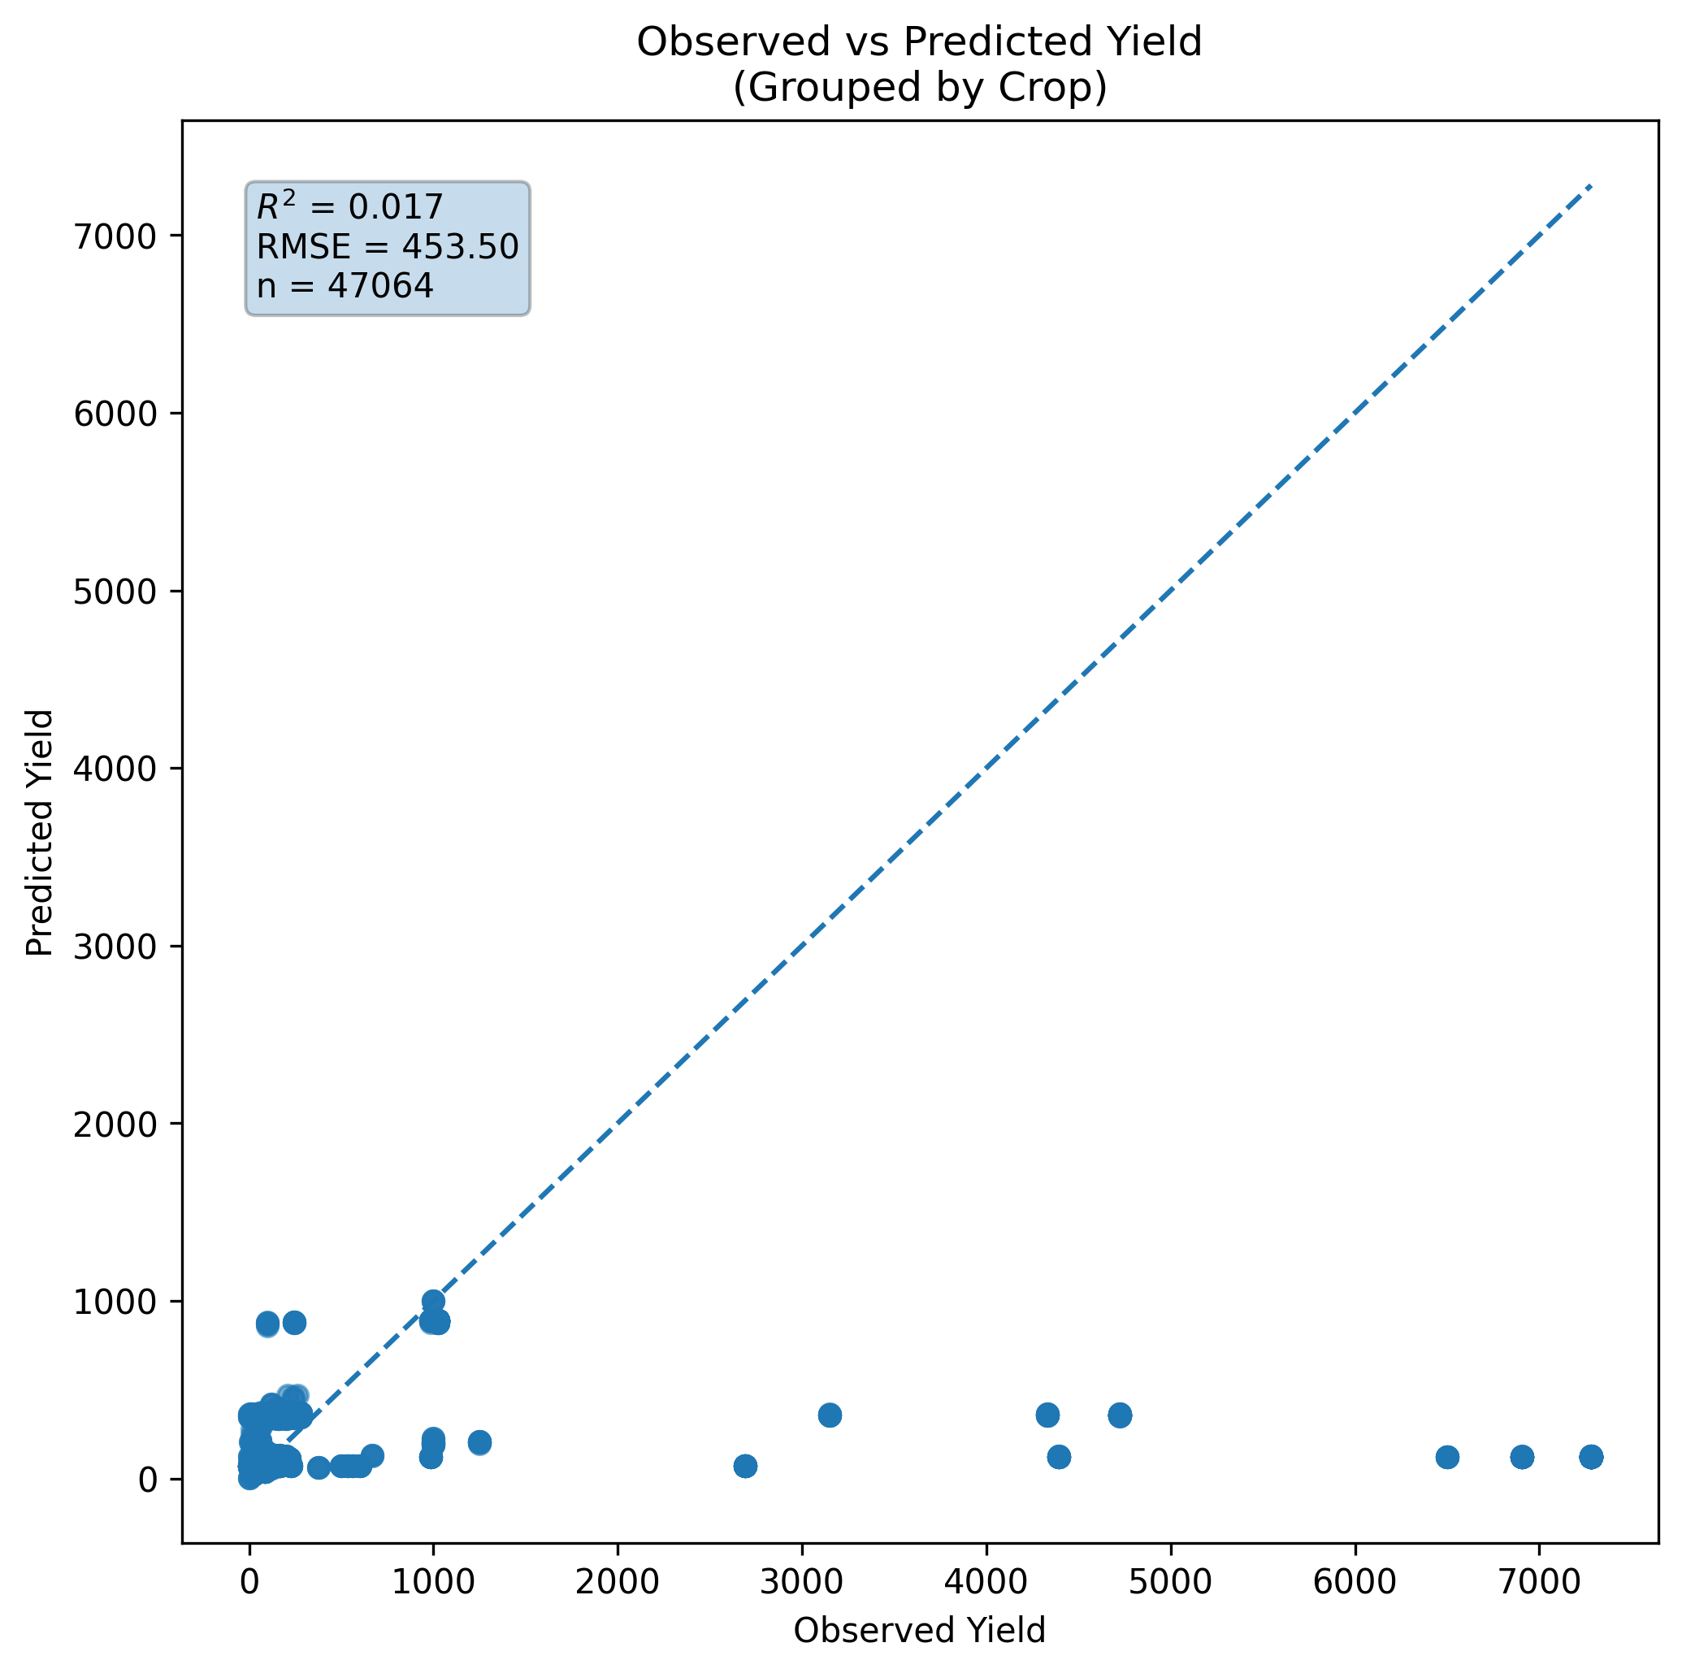
Figure 3: Observed vs Predicted Yield Using Grouped by Crop 5 Fold CV
6.4 Leave-One-Crop-Out Cross Validation
Each crop was treated as one fold.
Result:
- R² ≈ 0.17
Interpretation: Limited cross-crop transferability exists, the model struggles to extrapolate across crop species.
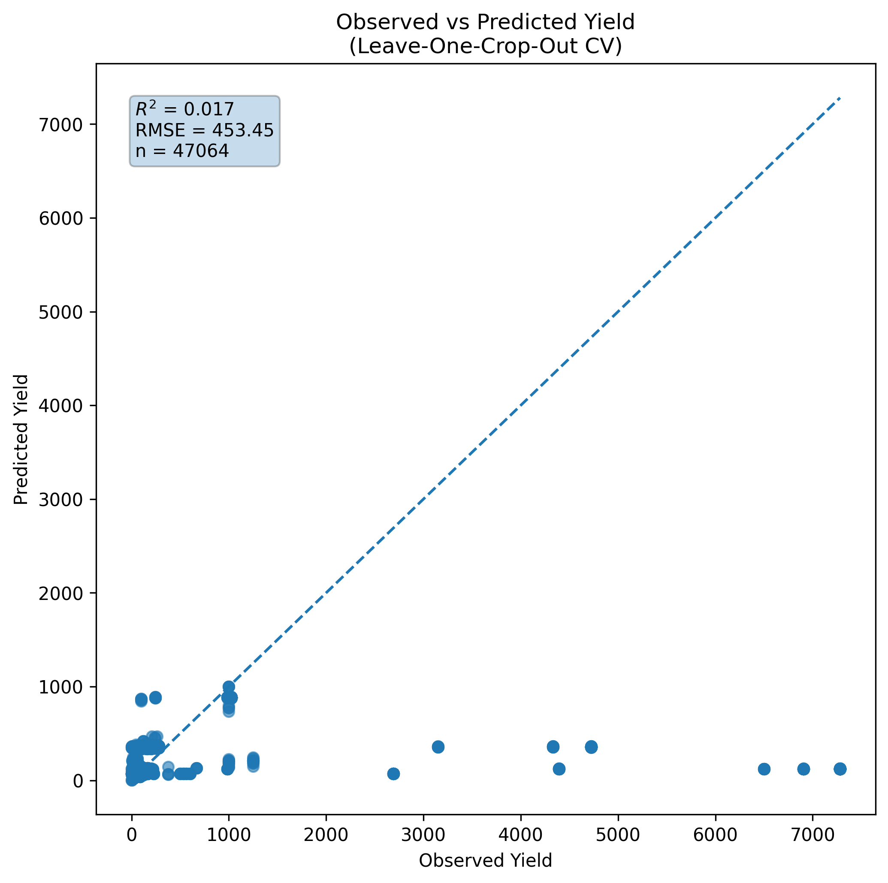
Figure 4: Observed vs Predicted Yield Using Leave One Crop Out Cross Validation
6.5 Leave-One-County-Out Cross Validation
Each county was held out individually.
Result:
- R² ≈ 0.07
Interpretation: Limited cross-county transferability exists, the model struggles to extrapolate across counties.
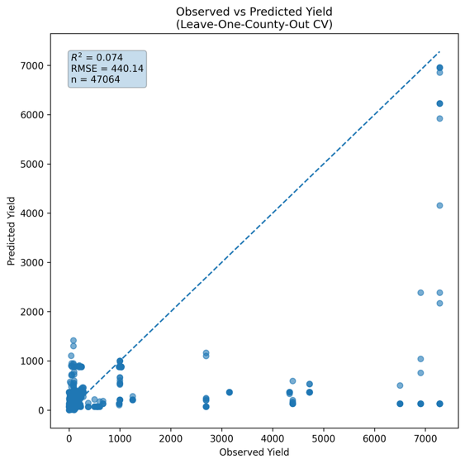
Figure: Observed vs Predicted Yield Using Leave-One-County-Out CV
7. Feature Importance Analysis
Feature importance analysis consistently identified:
- Variety
- Crop identity
- Acres
- Nutrient rates
- Herbicide indicators
High importance of crop and variety confirms biological specificity.
High importance of acres may reflect total yield modeling rather than per-acre yield.
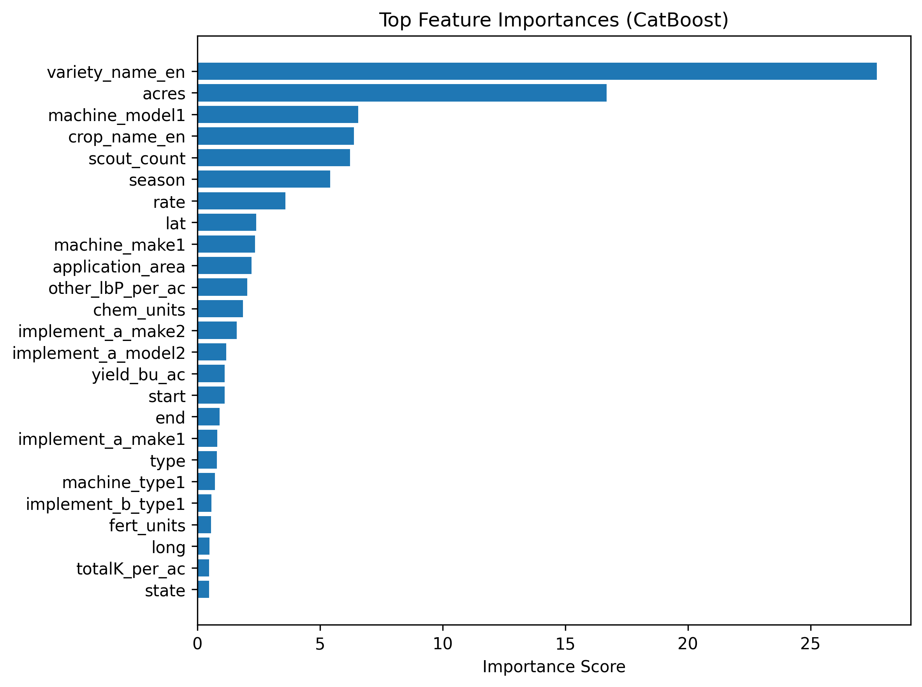
Figure: Top 25 Most Informative variables
8. Interpretation of Results
The experiments reveal several key insights:
- Management practices explain substantial variation within crop-location yield.
- Cross-location generalization is weak.
- Cross-crop generalization is biologically limited.
10. Model Deployment
The final most performing model was saved as: yield_catboost_model.cbm
11. Conclusions
The CatBoost model successfully captures within-crop yield variability driven by management practices. However, Yield is highly location-dependent. Cross-crop extrapolation is weak.

